**Project Design Phase-II**

**Data Flow Diagram & User Stories**

|  |  |
| --- | --- |
| Date | 03 October 2022 |
| Team ID | PNT2022TMI16946 |
| Project Name | Project –IoT based safety gadget for child safety monitoring and notification |
| Maximum Marks | 4 Marks |

**Data Flow Diagrams:**

A Data Flow Diagram (DFD) is a traditional visual representation of the information flows within a system. A neat and clear DFD can depict the right amount of the system requirement graphically. It shows how data enters and leaves the system, what changes the information, and where data is stored.

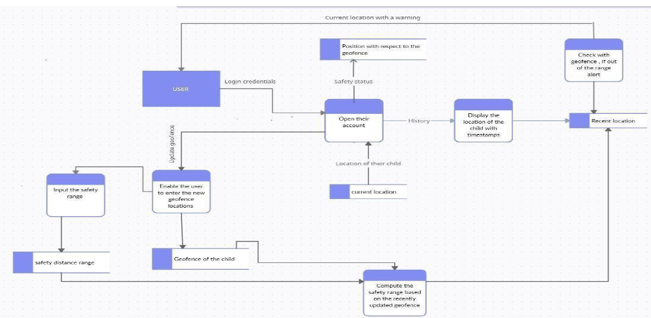

**User Stories**

Use the below template to list all the user stories for the product.

| **User Type** | **Functional Requirement (Epic)** | **User Story Number** | **User Story / Task** | **Acceptance criteria** | **Priority** | **Release** |
| --- | --- | --- | --- | --- | --- | --- |
| Customer (Mobile user) | Registration | USN-1 | As a user, I can register for the application by entering my email, password, and confirming my password. | I can access my account / dashboard | High | Sprint-1 |
|  |  | USN-2 | As a user, I will receive confirmation email once I have registered for the application | I can receive confirmation email & click confirm | High | Sprint-1 |
|  |  | USN-3 | As a user, I can register for the application through Facebook | I can register & access the dashboard with Facebook Login | Low | Sprint-2 |
|  |  | USN-4 | As a user, I can register for the application through Gmail | I can register and access the dashboard with a gmail account login | Medium | Sprint-1 |
|  | Login | USN-5 | As a user, I can log into the application by entering email & password | I can receive a verification mail and verify it | High | Sprint-1 |
|  | Dashboard | USN-6 | As a user I can navigate to the dashboard after successfully login to the application | I can view the location which are accumulated in the database and other options available on the platform via the dashboard | High | Sprint-2 |
| Customer (Web user) | Notification | USN-7 | As a user when there is an anomalous situation with the child a notification will be received through the fencing application | An alert message is sent to the parents mobile and received if the user is engaged them and intricacies. | High | Sprint-1 |
| Customer Care Executive | Support | USN-8 | As a user I can connect with experts to clear queries they assist to overcome challenges by scanning for any glitches and monitoring the operation and by checking if all the users are authorized. | I can login with my given credentials to chat/call them and get clarity about any intricacies. | Medium | Sprint-3 |
| Administrator | Login | USN-9 | As an administrator I can set the geofence location limit and make sure the database encompassing the locations is secure factual and updated constantly | I can login with my provided credentials and can exploit the prospects open on the dashboard. | High | Sprint-3 |